
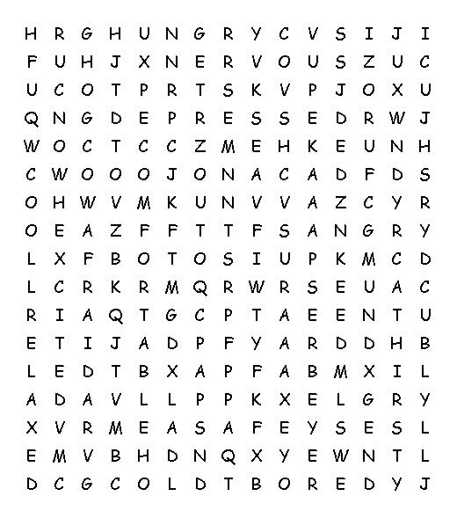 |  |  | Find the words below in the grid to the left.  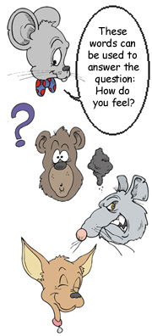
afraid  angry  bored  cold  comfortable  confused  cool | depressed  excited  happy  hot  hungry  nervous  relaxed | sad  safe  thirsty  tired  uncomfortable  warm

© 2006 www.bogglesworldesl.com

